**Supplementary material**

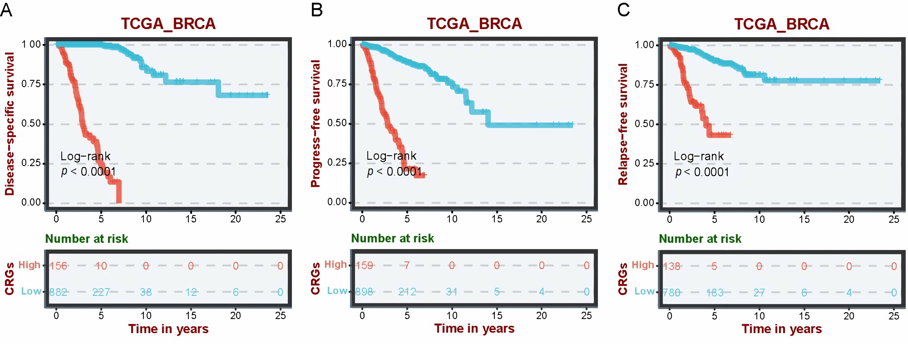

**Supplementary Fig. 1. Prognostic analysis of BRCA patients with distinct RSF scores.** (A) Disease-specific survival, (B) Progression-free survival, and (C) Relapse-free survival. The prognostic index of BRCA patients was calculated as the sum of individual survival tree predictions, aggregating risk estimates from all trees to provide a combined risk score for each observation. BRCA: breast cancer; RSF: random survival forest; CRGs: cuproptosis-related genes; TCGA_BRCA: The Cancer Genome Atlas_Breast Cancer.